FOOD PRODUCTION AND SUPPLY IN AFRICA

**INTRODUCTION**

The security of food production and supply is something that affects us all. Producers of agricultural and large food chains have to produce more food with less land and raw materials. The global food problem is as a result of the lack of food provision for the Earth’s population. It manifests itself primarily in the poorest countries of the Third World and is currently aggravating as the populations of these countries grow. The total number of people suffering from this lack of food is over one billion people worldwide. The fact is that population growth outpaces the growth of agricultural production and the development of agricultural technologies.

**AIMS AND OBJECTIVES**

In this analysis, I will be using the datasets of food production, supply and estimated population of about 45 African countries between 2004-2013 to see how the problem of food security and be solved or reduced drastically.

Firstly, the dataset for the food production is imported into pandas in the jupyter notebook, after which I created functions to convert the dates as integer to [date object](https://www.google.com/url?q=http://reference.wolfram.com/language/ref/DateObject.html&sa=D&ust=1583253221881000) and added units (1000 tons [metric kilotons]) to values

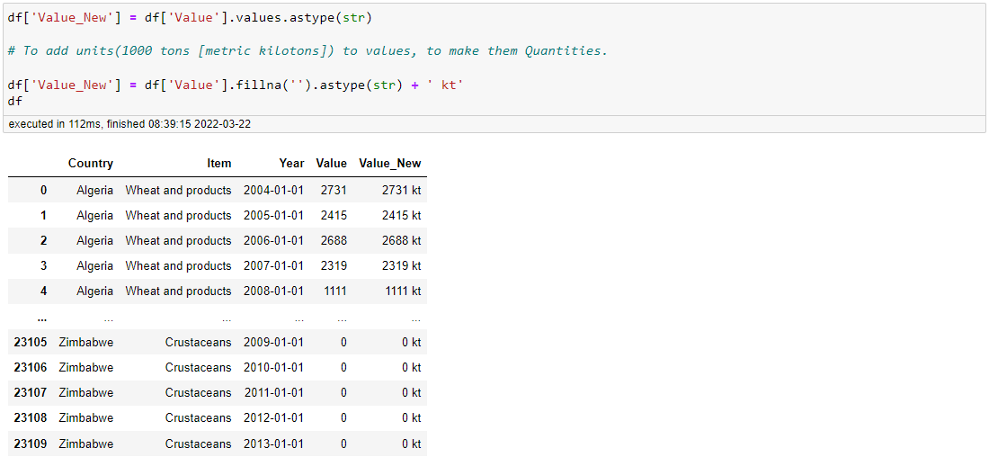

Then did a group by of the Dataset to see the quantities of food items supplied by each country on a yearly basis. The same processes were applied to the food supply dataset but vary in that instead of adding kiloton to value (string data type), I added kcal/person/day and proceeded to grouping the dataset.

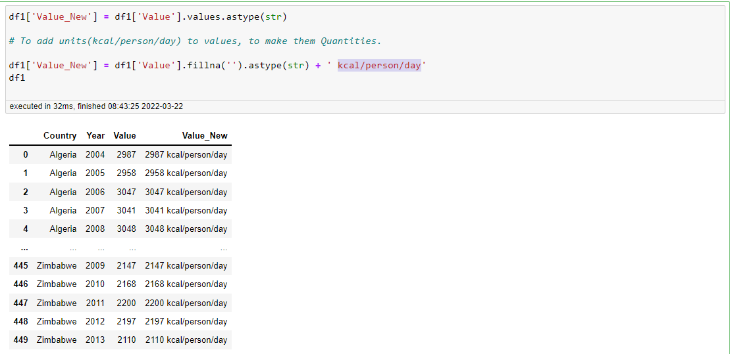

I then proceeded to data visualization. I initially used subplot to check the outliers in both datasets, as well as Using IQR (Inter Quartile Range) to detect and removing outliers. The Interquartile Range (IQR) is calculated as Q3-Q1

This tells us about the dispersion of the dataset, and helps us to find outliers. Any value that falls below the lower fence or above the upper fence is considered an outlier. Lower fence = Q1 - 1.5(IQR) Upper fence = Q3 + 1.5(IQR)

Q1 = np.percentile(df['Value'], 25,

interpolation = 'midpoint')

Q3 = np.percentile(df['Value'], 75,

interpolation = 'midpoint')

IQR = Q3 - Q1

print("Old Shape: ", df.shape)

# Upper bound

upper = np.where(df['Value'] >= (Q3+1.5*IQR))

# Lower bound

lower = np.where(df['Value'] <= (Q1-1.5*IQR))

''' Removing the Outliers '''

df.drop(upper[0], inplace = True)

df.drop(lower[0], inplace = True)

print("New Shape: ", df.shape)

OUTPUT: Old Shape: (23110, 5)

New Shape: (19414, 5)

Furthermore, I used part of the above calculation to create a box plot, to appreciate the Average and median food supplied, the outliers, Quartile and interquartile ranges.

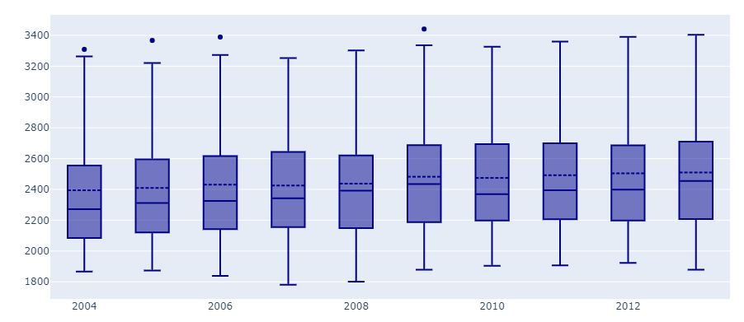

''In creating a boxplot of the food supply data for each year. We were able to discover that there is just one outlier in 2012 (value = 3390) ''

A further instruction was given to extract the data for year 2012 to explore the more. So after extracting the data, I imported Itertools needed for the next plot, Printed the mean value of 2012 dataset and how it was repeated in a list. Found the outlier

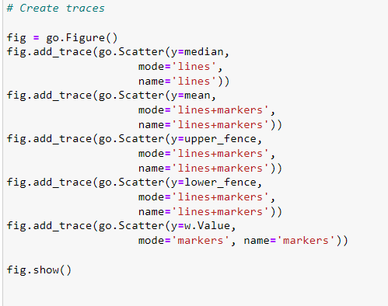

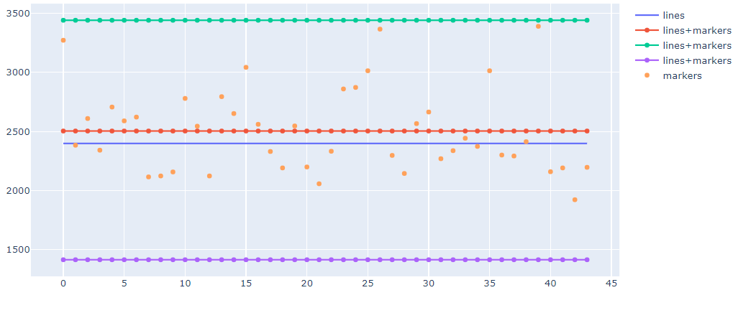

We then discovered that the country that has the only outlier in 2012 was Egypt and Egypt supplies 3561 kcal/person/day. So, we can conclude that in 2012, Egypt had significantly higher food available for consumption than other African countries.

Moreso, the data containing the population of the African countries was imported, which aided us further into the analysis. We then looked at the mean production of Rice been one of the food items produced as against the population of the countries within those period of 10 years and went ahead to do the hypothesis testing of the new datasets(Yearly Mean production of rice by annual population of these countries between 2004-2013).

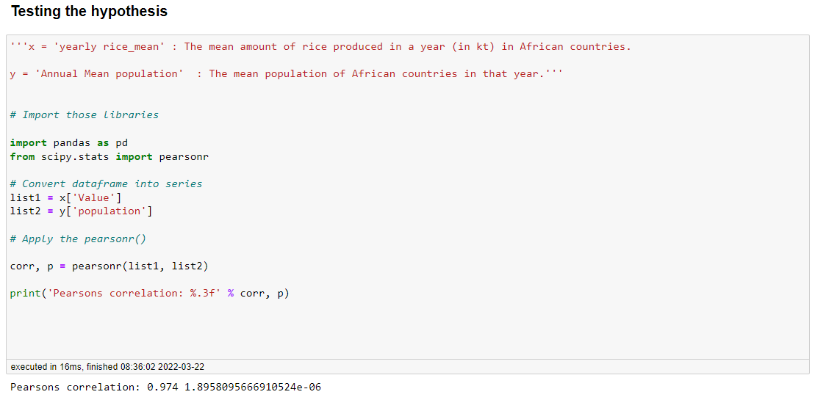

We can infer that the test statistic is the correlation value between our two variables X and Y. The probability value, or P-value, is an indication of how likely it is that the null hypothesis is true. Our results show a correlation of 0.97, which is very high and a p-value of 3.1 x 10—6.

Therefore, we can conclude that: “the correlation coefficient (0.97) is significantly far from 0. That is, there is a significant correlation between mean rice production in a year, and the mean population of African countries for that year.”

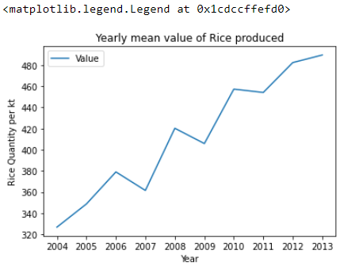 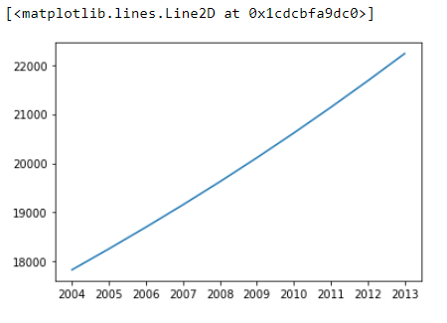

I went further to compare these two variables in the charts above, and saw that there was a rise in mean rice production yearly from 326.789474 in 2004 but a drop was observed in 2007 to 361.500000, increased again, dropped to 405.842105 in 2009, after a continual increase was observed till 2013 with about 489.578947 kt while the population of the African Nations keeps increasing per year which is one of the leading causes of food scarcity in the Region. To bridge this gap, we can either put things in place to check population increase or increase our food production to meet the demand.

**Quantity of Rice Produced Per Country**

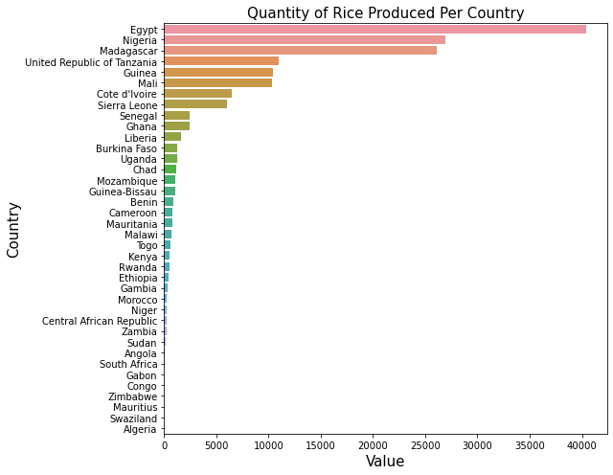

**We can infer from this chart that Egypt is the highest producer of rice (40,370), followed by Nigeria (26,964) and then Madagascar (26,118).**

**Yearly Trend of Total Food Production and Total Food Supplied per year**

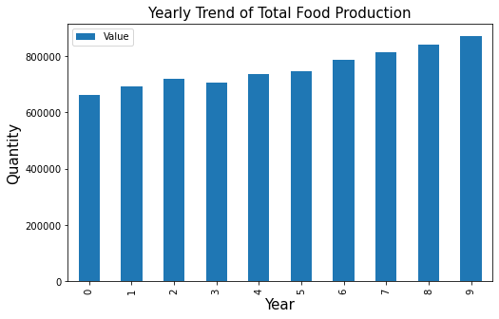 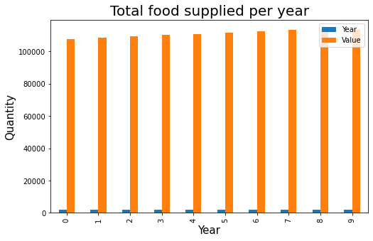

The production of food items keeps increasing on a yearly basis from 2004, but dropped between 2006 and 2007, which later pick up and has been increasing per year. The maximum production of food was observed in 2013, about 110,429 kilotons while the total food supply chain increased from 2004-2013 from 107,740 - 113,951 kcal.

**Quantity of All food Items produced per country**

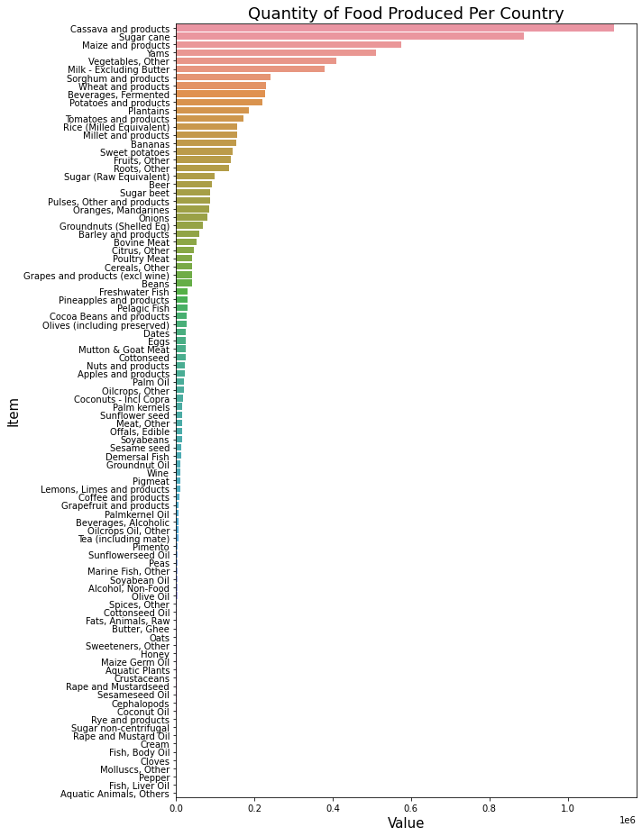

We found that the most produced food item in Africa between 2004-2013 was Cassava and products (1,118,948 kt), Sugar cane (887,008) then, Maize and products (574,948kt).

In addition, I went further to analysis **the countries that produced the most, it was discovered that Nigeria, followed by Egypt the South Africa were the top food producing countries between 2004 - 2013.**

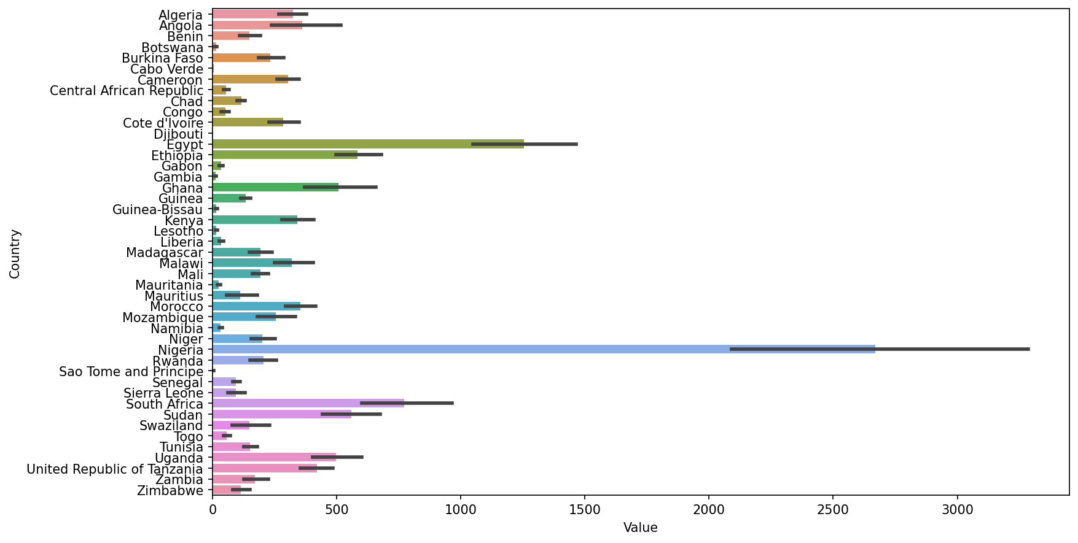

**Total food supplied per country**

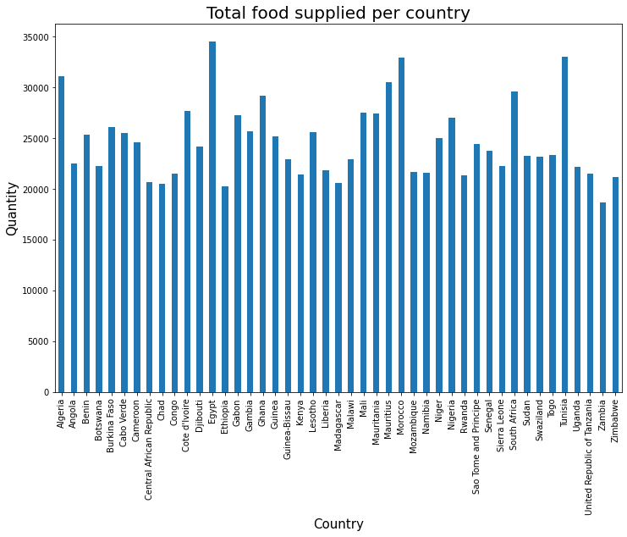

**Grouping the dataset by “Country” and visualizing to see that Egypt, Tunisia and Morocco then Algeria ranking 4th had the highest food supply.**

**Average and median food production, the outliers, Quartile and interquartile ranges with a Boxplot**

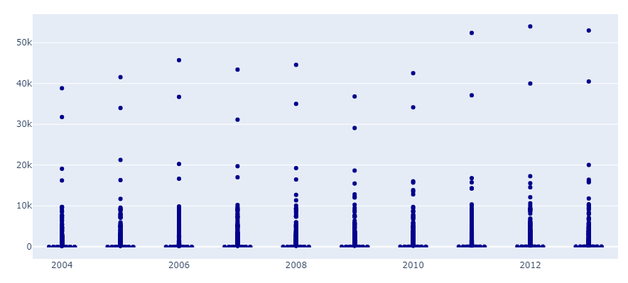

The using the above boxplot to check the Average and median food production, the outliers, Quartile and interquartile ranges, we discovered year 2012 had the highest value of outlier about 54k, the average/mean of food produced that year was 364.8316, Median is 22k, the 1st quartile is 3 while the 3rd quartile is 122. Therefore, the interquartile range is 3-122.

**Food items in Nigeria per Kiloton**

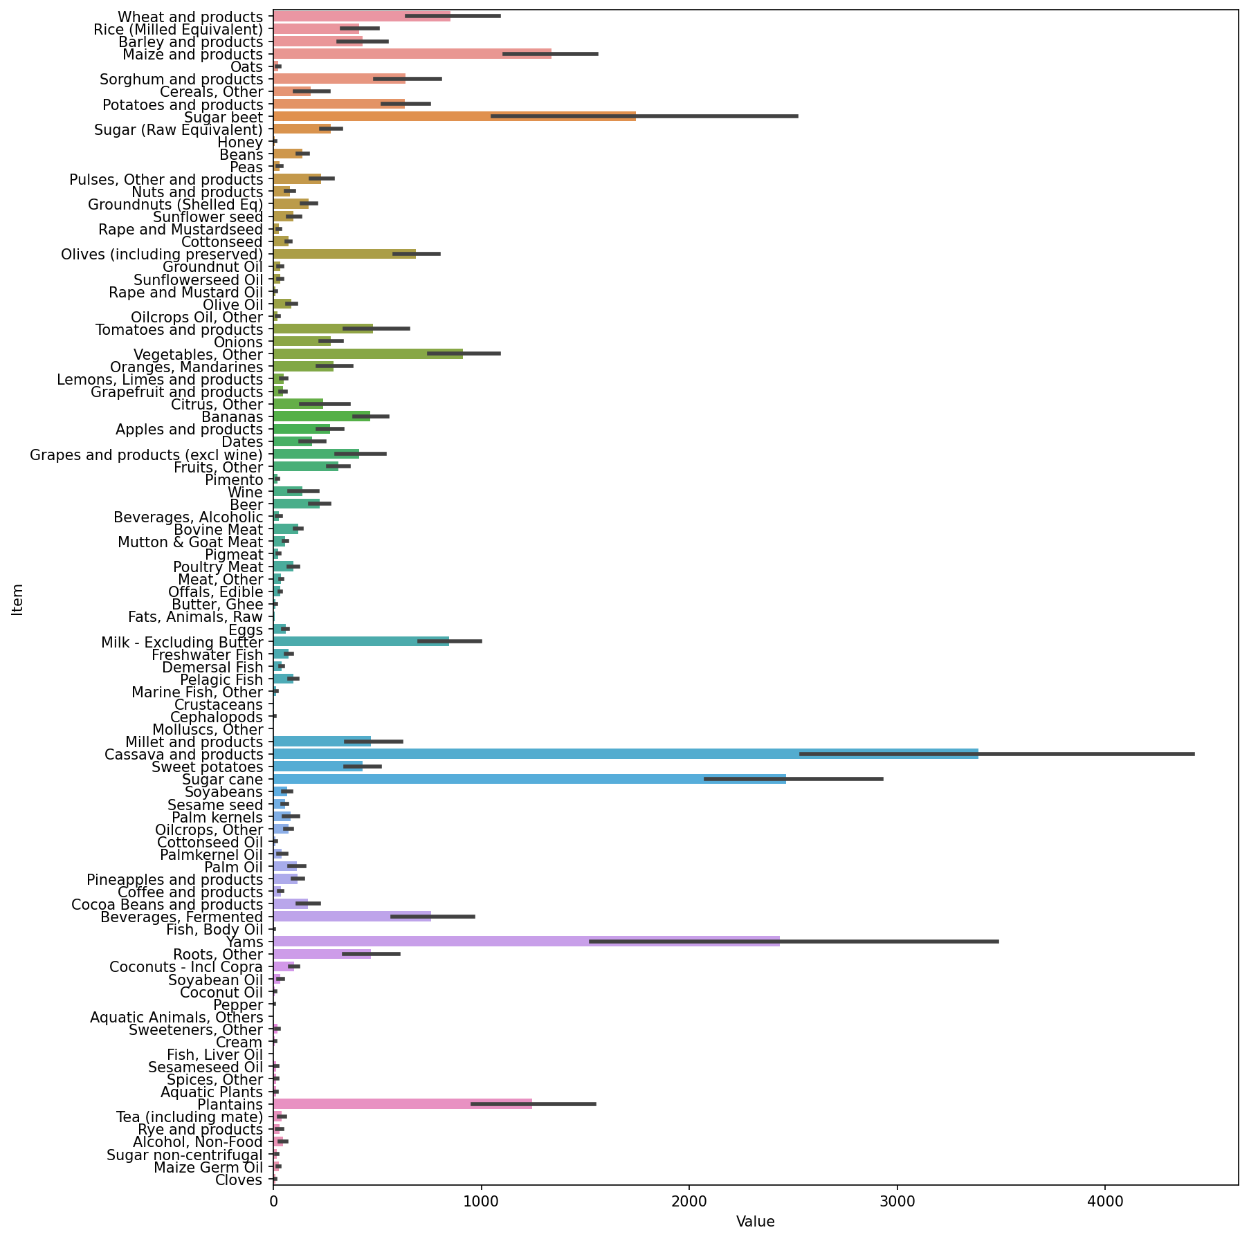

Using Nigeria as example, I will to appreciate most produced food items in Nigeria. Cassava and products, sugar cane, yams were the most produced food. While there are some food items that are not produced in Nigeria or produced in very small quantity, these are mostly food from water source, examples are fish, liver oil, mollusks and others.

From Analysis, Nigeria is food followed by Egypt. Nigeria couldn't be ranked among the 1st five food suppliers due to reasons like

* Continual increase in population
* Lack of good storage facilities
* Wastage of food
* Lack of policies put in place by the government to improve production and supply, among others.
* Lack of access to food, for example by income, and the nutritional value

**RECCOMENDATION**

There are different solutions for the world food problem, which may include:

* Improving the availability of food.
* The productivity of farmers must also improve by wider and better applying existing knowledge and technologies or by stimulating innovations.
* In fields as genetics, precision agriculture and new applications for agricultural products and residual streams (biobased).
* People must have some access to food, either economically and physically with disposable income, food prices and the availability and quality of the infrastructure.
* The food has to be balanced and healthy, safe and full of valuable nutrients.